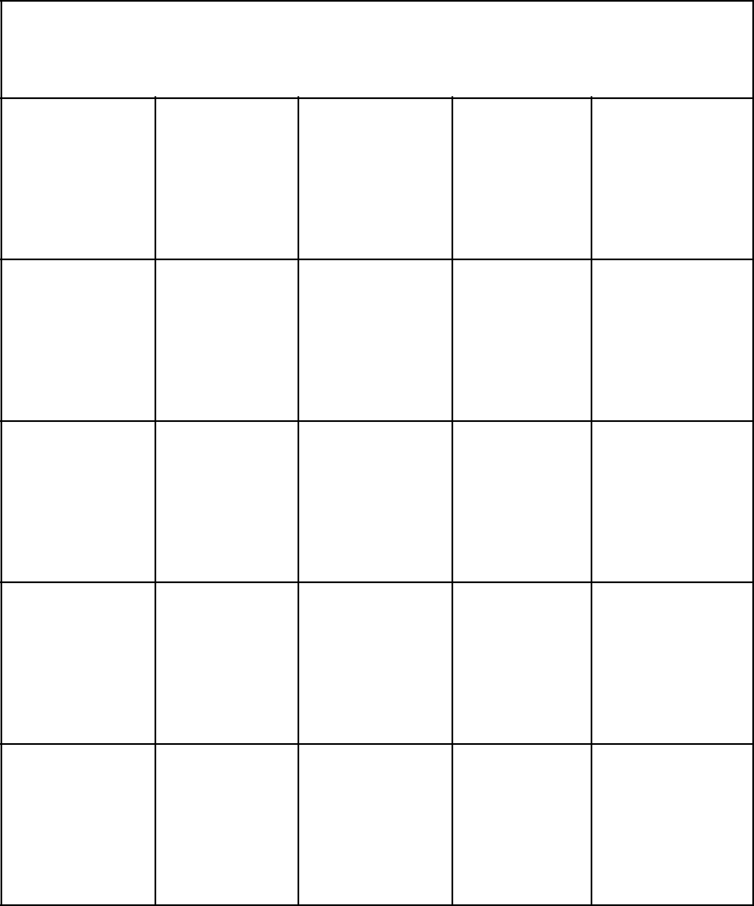**Schechter Experiences Bingo**

|  |  |  |  |  |
| --- | --- | --- | --- | --- |
| Yom | Physics Kehillah | Reading | DC Trip |  |
| Ha’Atzmaut | Torah |  |

|  |  |  |  |
| --- | --- | --- | --- |
| Outdoor Ed Graduation | Basketball | Chemistry | The |
|  | Team |  | Outsiders |

|  |  |  |  |  |  |
| --- | --- | --- | --- | --- | --- |
| Gym | Go Lions! | **FREE** | Schechter | Touching |  |
| **Free Space** | Bucks | The Lights |  |
|  |  |  |

|  |  |  |  |  |
| --- | --- | --- | --- | --- |
| Yom | Specials Nationalism | 5th Grade | Kindergarten |  |
| Ha’Zikaron | Shabbaton |  |

|  |  |  |  |  |  |
| --- | --- | --- | --- | --- | --- |
| Speak | World | Tribes | Joseph | Hagigat |  |
| Wars | Play | Ha’Gan |  |
|  |  |  |